**4th WEEK ASSIGNMENT**

**1)Deploy .net app in azure dev ops from azure demo generator**

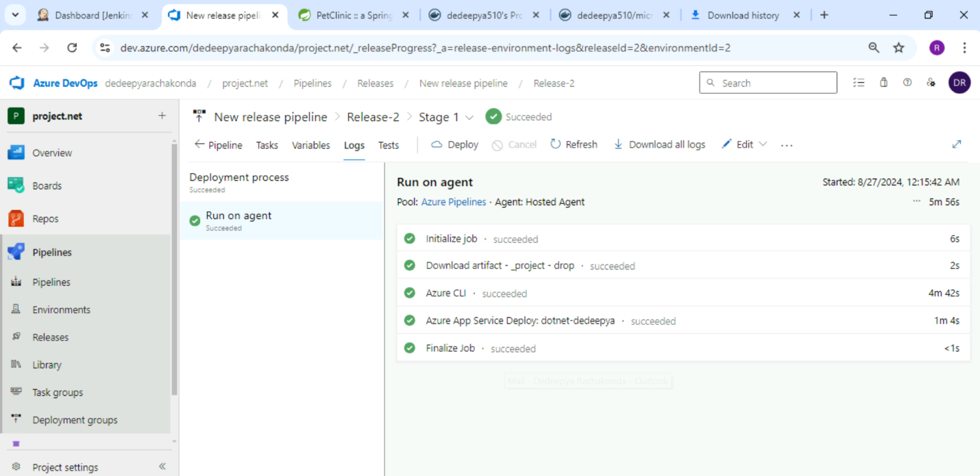

**2)** **Deploy the pet clinic in azure dev ops.**

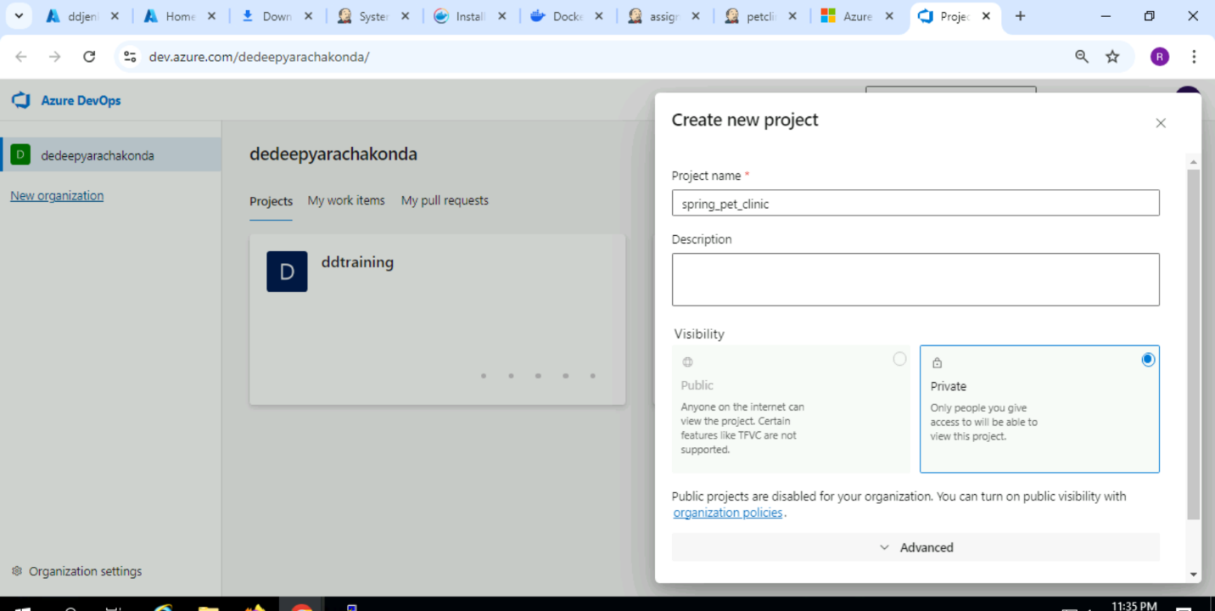

**3) Bitbucket**

**-create a project**

**-create a repo**

**- push existing code**

**-create a branch**

**-demonstrate pull request**

First create a new project….

**Add a branch….**

**Add new file in dd1 ….**

**Then merge ….**

**4) Create Jenkins freestyle pipeline**

**- spring pet clinic jar creation**

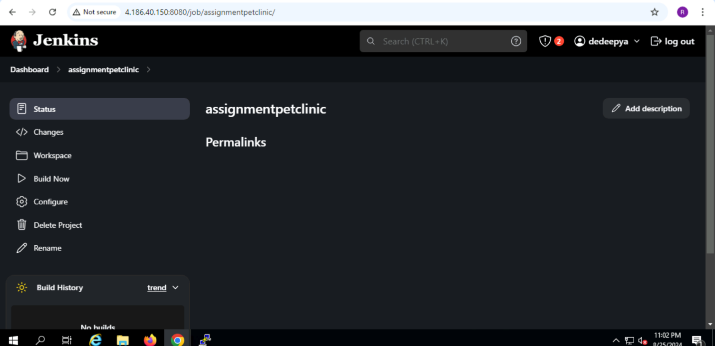

**5) Create a pipeline in Jenkins**

**-spring pet clinic jar creation**

